Water Tank Monitoring System

Team Members
- SHAIK REHAAN ASHRAF (AM.EN.U4CSE22153)
- ROHIT VARMA DATLA (AM.EN.U4CSE22119)
- DARSHAN KUMAR (AM.EN.U4CSE22114)
- SAHODEV (AM.EN.U4CSE22172)
- ATHULYA (AM.EN.U4CSE22068)

Abstract
The "Water Tank Monitoring System" offers a practical solution to address water scarcity by mitigating wastage caused by overflow. This system employs Arduino Uno microcontroller-based automation to monitor water levels in real-time, using ultrasonic sensors. It controls the motor operation, ensuring optimal water usage and energy efficiency. The system can also alert users through visual (LCD), auditory (buzzer), and optional remote notifications via a smartphone app, enhancing convenience and safety.

Working Principle
- Water Level Detection: Ultrasonic sensors emit sound waves, measure the time for echoes to return, and calculate the water level based on the speed of sound.
- Processing: The Arduino Uno processes the input data from the sensors to assess water levels in the tank.
- Control: The motor is activated when the water level drops below a set threshold and automatically turned off when the tank is full, preventing overflow.
- Alert Mechanism:
  - Buzzer: Alerts users if the water level is critically low or abnormal.
  - LCD Display: Continuously displays the water level status.
  - Mobile App (optional): Sends notifications and allows users to monitor and control the motor remotely.

Block Diagram
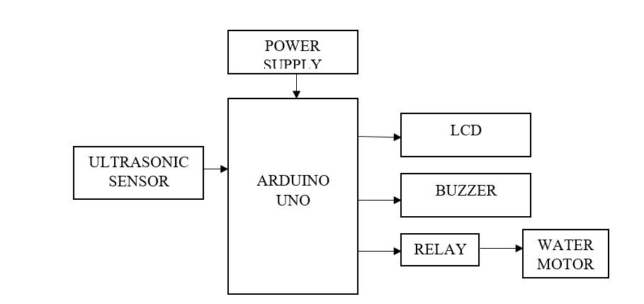

- Sensors: Ultrasonic sensor for level detection.
- Controller: Arduino Uno for data processing and decision-making.
- Outputs:
  - LCD for visual status.
  - Buzzer for alerts.
  - Motor relay for controlling water pump operation.
- Power Supply: Provides power to the Arduino and other components.

Hardware Requirements
- · POWER SUPPLY
- · ARDUINO UNO
- · LCD
- · BUZZER
- · ULTRASONIC SENSOR
- · RELAY
- · WATER MOTOR

Software Requirements
- Arduino IDE
- Programming in C Language

Applications
- Residential Water Management: Prevents tank overflow, saving water and energy.
- Industrial Applications: Controls water levels in storage tanks in factories or chemical plants.
- Remote Monitoring: Integrated with IoT for smartphone notifications and motor control.
- Agriculture: Ensures efficient water management for irrigation systems.

Advantages
- Reduces water wastage and energy consumption.
- Cost-effective and easy to implement.
- Enhances convenience through automation and app-based control.

Future Scope
- Integrating AI to predict water usage patterns for better efficiency.
- Adding solar-powered motors for sustainability.
- Incorporating GSM or Wi-Fi modules for global monitoring and control.

